=================================================================================
一、solidity简单代币到销毁机制，分红机制，防机器人，营销手续费等一个完整代币(bsc链)_博文只是为了整理笔记的博客-程序员ITS201
技术标签： 区块链 bsc 数字货币 智能合约 以太坊
在浏览了全网发现都没有一个现今完整机制的代币资源，决定自己来写一个博客。
目录
二、代币的销毁机制
三、代币的防机器人机制
四、代币营销手续费
五、一个完整项目代币，包括以往未实现的分红，添加流动性等

一、使用remix在线编辑器写简单代币
编辑器地址：remix.ethereum.org 注：需要翻墙

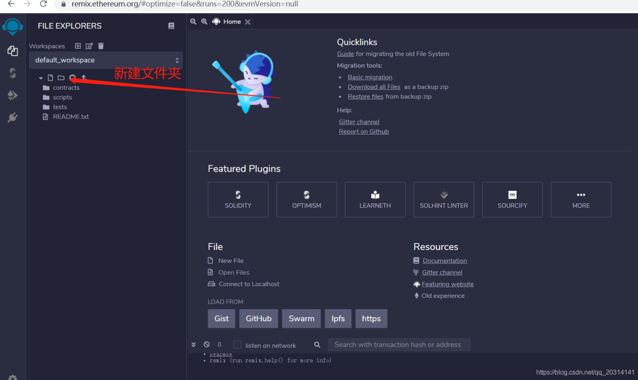

上面是这个在线编辑器， 我们先新建个文件夹

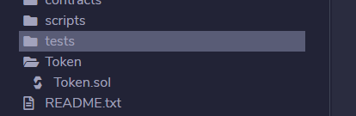
再建一个Token.sol文件。
Token.sol文件内容
// SPDX-License-Identifier: MIT
pragma solidity ^0.6.2;
import "./ERC20.sol";
contract Token is ERC20{

string private _name; //代币名字
string private _symbol; //代币符号
/*
* @dev 返回代币的名字
*/
function name() public view virtual returns (string memory) {
return _name;
}
/**
* @dev 返回代币的符号
*/
function symbol() public view virtual returns (string memory) {
return _symbol;
}
/**
* 返回代币精度
*/
function decimals() public pure virtual returns (uint8) {
return 18;
}
constructor() public{
_name='Token';
_symbol='Tk';
_mint(msg.sender, 10000000000000 * (10 ** 18)); //铸币给连接此合约的账号于10000000000000个币;
}
//交易函数
function _transfer(address recipient,uint256 amount) public returns(bool){
return super.transfer(recipient, amount); //发送代币
}
function _transferFrom(address sender,address recipient,uint256 amount) public returns(bool){
return super.transferFrom(sender,recipient,amount); //发送代币
}
}
在这代码中我们实现了一个简单代币功能，ERC20.sol是一个以太坊的库。里面包括了一系列的针对代币的方法。ERC20.sol的代码我会在后面贴出来。这里的_mint是ERC20的一个铸币方法。参数是_mint(address account, uint256 amount)指给左边地址多少个amount的币。
接着我们配置metamask的测试网络配置如下：
NetWork Name: BSC TestnetRPC URL：https://data-seed-prebsc-1-s3.binance.org:8545/ID：97符号：BNBURL：https://testnet.bscscan.com/

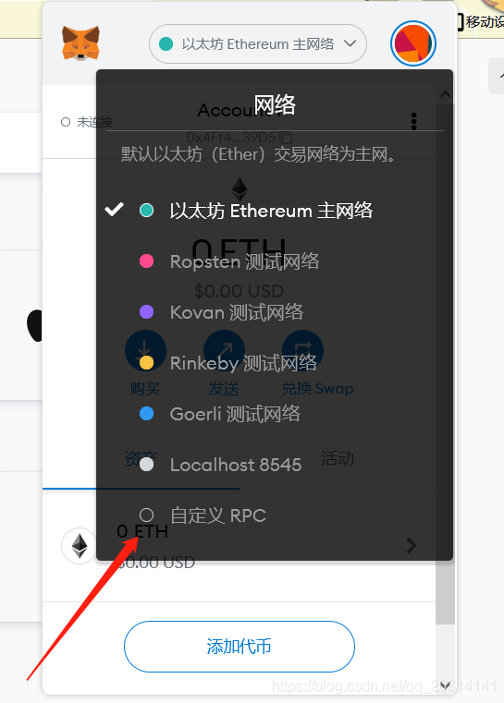

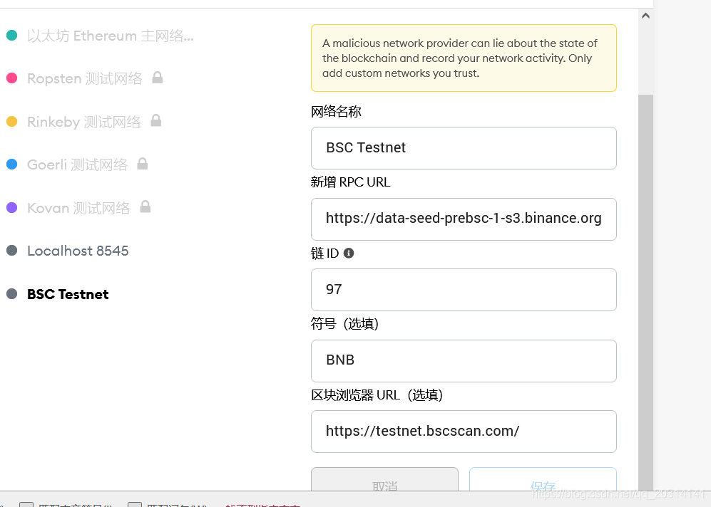

再去 https://testnet.binance.org/faucet-smart里面输入的地址领取测试币
之后再部署这个代币到bsc测试链里面

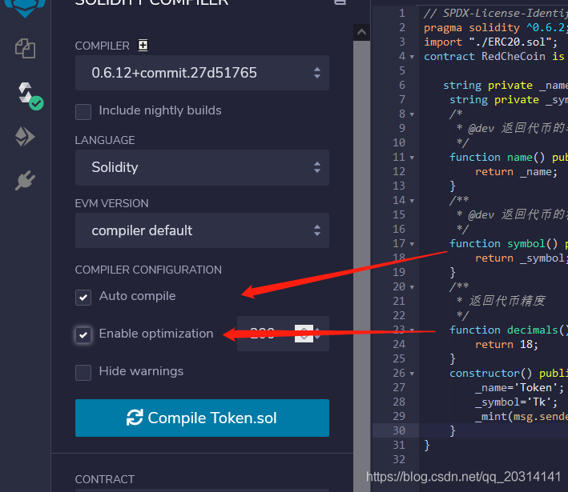
根据从上到下箭头依次选择即可

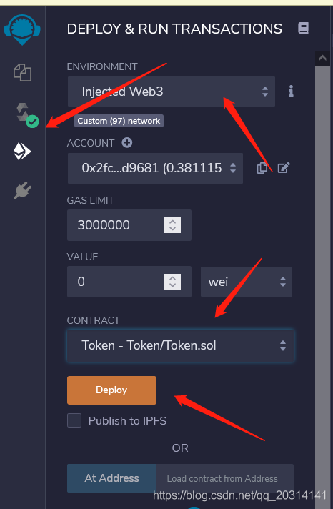
这是部署之后的

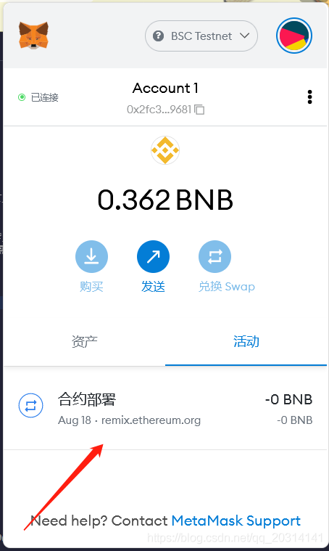
点击浏览器打开

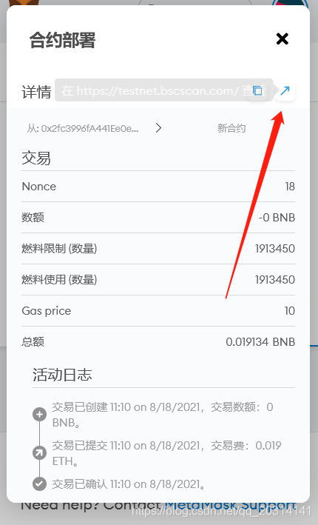
这个就是你的合约地址了，之后添加该代币

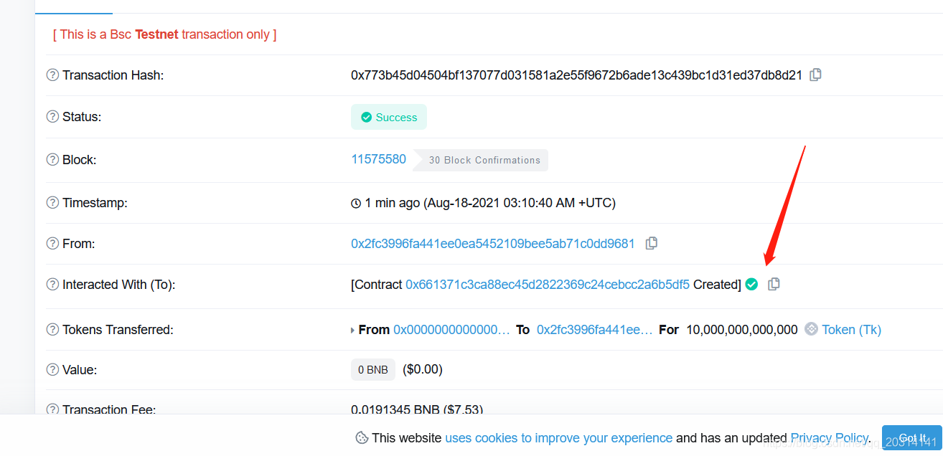

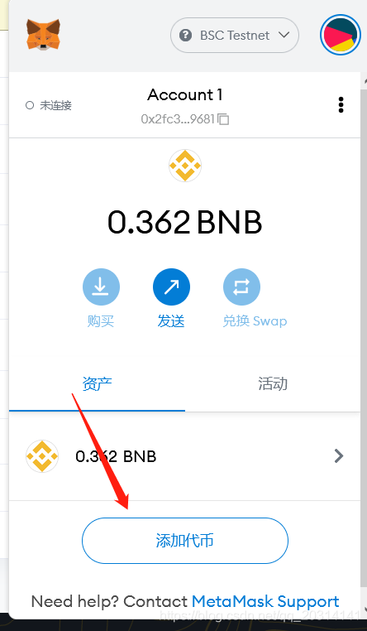

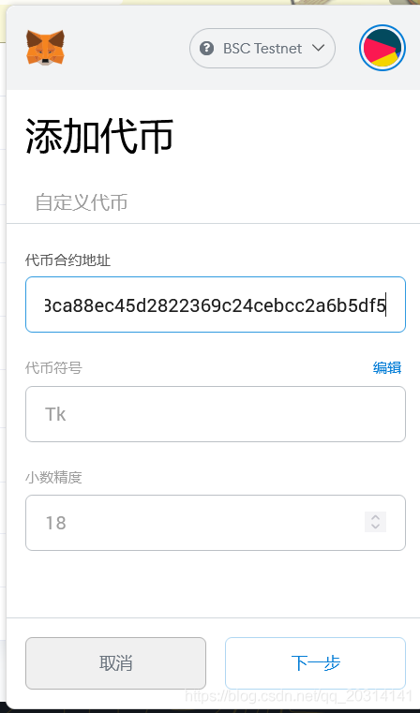
添加完之后我们可以部署去测试pancake，添加流动性。测试交易等
pancakeswap测试地址：https://pancake.kiemtienonline360.com/#/pool

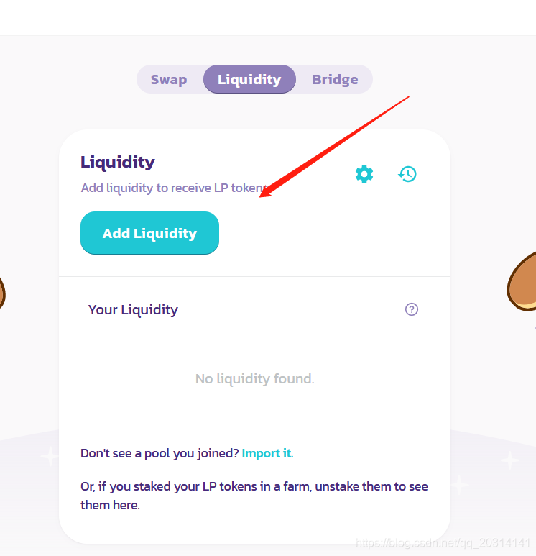

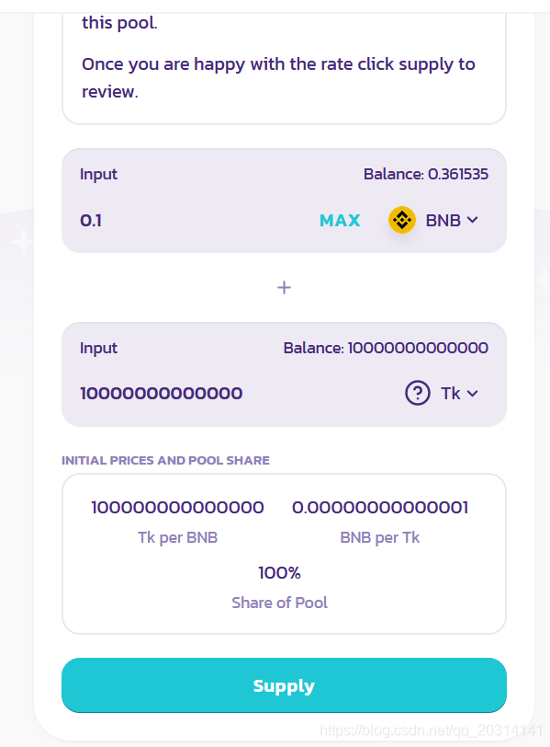

最后就能测试交易了

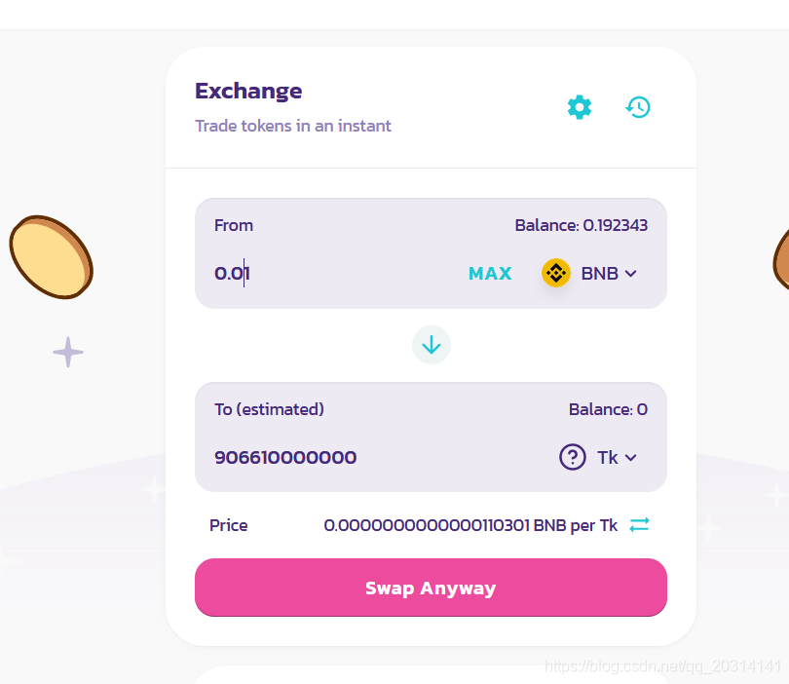

ERC20.sol代码，ERC20.sol实现了IERC20接口的一系列方法，有铸币，交易，转账等基础方法。
// SPDX-License-Identifier: Unlicensed
pragma solidity ^0.6.2;
import "./IERC20.sol";
import "./SafeMath.sol";
contract ERC20 is IERC20 {
using SafeMath for uint256;

mapping (address => uint256) internal _balances;

mapping (address => mapping (address => uint256)) internal _allowances;

uint256 private _totalSupply;

/**
* @dev See `IERC20.totalSupply`.
*/
function totalSupply() public override view returns (uint256) {
return _totalSupply;
}

/**
* @dev See `IERC20.balanceOf`.
*/
function balanceOf(address account) public override view returns (uint256) {
return _balances[account];
}

/**
* @dev See `IERC20.transfer`.
*
* Requirements:
*
* - `recipient` cannot be the zero address.
* - the caller must have a balance of at least `amount`.
*/
function transfer(address recipient, uint256 amount) public override returns (bool) {
_transfer(msg.sender, recipient, amount);
return true;
}

/**
* @dev See `IERC20.allowance`.
*/
function allowance(address owner, address spender) public override view returns (uint256) {
return _allowances[owner][spender];
}

/**
* @dev See `IERC20.approve`.
*
* Requirements:
*
* - `spender` cannot be the zero address.
*/
function approve(address spender, uint256 value) public override returns (bool) {
_approve(msg.sender, spender, value);
return true;
}

/**
* @dev See `IERC20.transferFrom`.
*
* Emits an `Approval` event indicating the updated allowance. This is not
* required by the EIP. See the note at the beginning of `ERC20`;
*
* Requirements:
* - `sender` and `recipient` cannot be the zero address.
* - `sender` must have a balance of at least `value`.
* - the caller must have allowance for `sender`'s tokens of at least
* `amount`.
*/
function transferFrom(address sender, address recipient, uint256 amount) public override returns (bool) {
_transfer(sender, recipient, amount);
_approve(sender, msg.sender, _allowances[sender][msg.sender].sub(amount));
return true;
}

/**
* @dev Atomically increases the allowance granted to `spender` by the caller.
*
* This is an alternative to `approve` that can be used as a mitigation for
* problems described in `IERC20.approve`.
*
* Emits an `Approval` event indicating the updated allowance.
*
* Requirements:
*
* - `spender` cannot be the zero address.
*/
function increaseAllowance(address spender, uint256 addedValue) public returns (bool) {
_approve(msg.sender, spender, _allowances[msg.sender][spender].add(addedValue));
return true;
}

/**
* @dev Atomically decreases the allowance granted to `spender` by the caller.
*
* This is an alternative to `approve` that can be used as a mitigation for
* problems described in `IERC20.approve`.
*
* Emits an `Approval` event indicating the updated allowance.
*
* Requirements:
*
* - `spender` cannot be the zero address.
* - `spender` must have allowance for the caller of at least
* `subtractedValue`.
*/
function decreaseAllowance(address spender, uint256 subtractedValue) public returns (bool) {
_approve(msg.sender, spender, _allowances[msg.sender][spender].sub(subtractedValue));
return true;
}

/**
* @dev Moves tokens `amount` from `sender` to `recipient`.
*
* This is internal function is equivalent to `transfer`, and can be used to
* e.g. implement automatic token fees, slashing mechanisms, etc.
*
* Emits a `Transfer` event.
*
* Requirements:
*
* - `sender` cannot be the zero address.
* - `recipient` cannot be the zero address.
* - `sender` must have a balance of at least `amount`.
*/
function _transfer(address sender, address recipient, uint256 amount) internal {
require(sender != address(0), "ERC20: transfer from the zero address");
require(recipient != address(0), "ERC20: transfer to the zero address");

_balances[sender] = _balances[sender].sub(amount);
_balances[recipient] = _balances[recipient].add(amount);
emit Transfer(sender, recipient, amount);
}

/** @dev Creates `amount` tokens and assigns them to `account`, increasing
* the total supply.
*
* Emits a `Transfer` event with `from` set to the zero address.
*
* Requirements
*
* - `to` cannot be the zero address.
*/
function _mint(address account, uint256 amount) internal {
require(account != address(0), "ERC20: mint to the zero address");

_totalSupply = _totalSupply.add(amount);
_balances[account] = _balances[account].add(amount);
emit Transfer(address(0), account, amount);
}

/**
* @dev Destoys `amount` tokens from `account`, reducing the
* total supply.
*
* Emits a `Transfer` event with `to` set to the zero address.
*
* Requirements
*
* - `account` cannot be the zero address.
* - `account` must have at least `amount` tokens.
*/
function _burn(address account, uint256 value) internal {
require(account != address(0), "ERC20: burn from the zero address");

_totalSupply = _totalSupply.sub(value);
_balances[account] = _balances[account].sub(value);
emit Transfer(account, address(0), value);
}

/**
* @dev Sets `amount` as the allowance of `spender` over the `owner`s tokens.
*
* This is internal function is equivalent to `approve`, and can be used to
* e.g. set automatic allowances for certain subsystems, etc.
*
* Emits an `Approval` event.
*
* Requirements:
*
* - `owner` cannot be the zero address.
* - `spender` cannot be the zero address.
*/
function _approve(address owner, address spender, uint256 value) internal {
require(owner != address(0), "ERC20: approve from the zero address");
require(spender != address(0), "ERC20: approve to the zero address");

_allowances[owner][spender] = value;
emit Approval(owner, spender, value);
}

/**
* @dev Destoys `amount` tokens from `account`.`amount` is then deducted
* from the caller's allowance.
*
* See `_burn` and `_approve`.
*/
function _burnFrom(address account, uint256 amount) internal {
_burn(account, amount);
_approve(account, msg.sender, _allowances[account][msg.sender].sub(amount));
}
}
IERC20.sol代码
// SPDX-License-Identifier: MIT License

pragma solidity ^0.6.2;

/**
* @dev Interface of the ERC20 standard as defined in the EIP.
*/
interface IERC20 {
/**
* @dev Returns the amount of tokens in existence.
*/
function totalSupply() external view returns (uint256);

/**
* @dev Returns the amount of tokens owned by `account`.
*/
function balanceOf(address account) external view returns (uint256);

/**
* @dev Moves `amount` tokens from the caller's account to `recipient`.
*
* Returns a boolean value indicating whether the operation succeeded.
*
* Emits a {Transfer} event.
*/
function transfer(address recipient, uint256 amount) external returns (bool);

/**
* @dev Returns the remaining number of tokens that `spender` will be
* allowed to spend on behalf of `owner` through {transferFrom}. This is
* zero by default.
*
* This value changes when {approve} or {transferFrom} are called.
*/
function allowance(address owner, address spender) external view returns (uint256);

/**
* @dev Sets `amount` as the allowance of `spender` over the caller's tokens.
*
* Returns a boolean value indicating whether the operation succeeded.
*
* IMPORTANT: Beware that changing an allowance with this method brings the risk
* that someone may use both the old and the new allowance by unfortunate
* transaction ordering. One possible solution to mitigate this race
* condition is to first reduce the spender's allowance to 0 and set the
* desired value afterwards:
* https://github.com/ethereum/EIPs/issues/20#issuecomment-263524729
*
* Emits an {Approval} event.
*/
function approve(address spender, uint256 amount) external returns (bool);

/**
* @dev Moves `amount` tokens from `sender` to `recipient` using the
* allowance mechanism. `amount` is then deducted from the caller's
* allowance.
*
* Returns a boolean value indicating whether the operation succeeded.
*
* Emits a {Transfer} event.
*/
function transferFrom(
address sender,
address recipient,
uint256 amount
) external returns (bool);

/**
* @dev Emitted when `value` tokens are moved from one account (`from`) to
* another (`to`).
*
* Note that `value` may be zero.
*/
event Transfer(address indexed from, address indexed to, uint256 value);

/**
* @dev Emitted when the allowance of a `spender` for an `owner` is set by
* a call to {approve}. `value` is the new allowance.
*/
event Approval(address indexed owner, address indexed spender, uint256 value);
}
其他内容之后更新
----------------------------------------------------------------------------------------------------------
二、代币的销毁机制_博文只是为了整理笔记的博客-程序员ITS201_apenft币有没有销毁机制
技术标签： 区块链 bsc 数字货币 智能合约 以太坊

在代币销毁中一般有两种，一种是代币项目方主动销毁代币，在这种一般是代币项目方将他们持有的币打进黑洞也就是0x0000000000000000000000000000000000000000地址。就是转账到这个地址。这篇主要讲每次交易中的一定比例打进黑洞
在上一篇代码的基础上改进
// SPDX-License-Identifier: MIT
pragma solidity ^0.6.2;
import "./ERC20.sol";
contract Token is ERC20{
string private _name;
string private _symbol;
address public deadwallet = 0x0000000000000000000000000000000000000000;//将代币打进这个地址就是销毁
address public LiquityWallet;
/*
* @dev 返回代币的名字
*/
function name() public view virtual returns (string memory) {
return _name;
}
/**
* @dev 返回代币的符号
*/
function symbol() public view virtual returns (string memory) {
return _symbol;
}
/**
* 返回代币精度
*/
function decimals() public pure virtual returns (uint8) {
return 18;
}
constructor() public{
_name='Token';
_symbol='Tk';
_mint(msg.sender, 10000000000000 * (10 ** 18)); //铸币给连接此合约的账号于10000000000000个币;
LiquityWallet=msg.sender;
}
//交易函数
function _transfer(address recipient, uint256 amount) public returns (bool) {
if(LiquityWallet!=msg.sender) return super.transfer(recipient, amount); //如果是铸币者则不需要交易销毁

uint256 BurnWallet = amount.mul(5).div(100); //每次交易销毁百分之5
uint256 trueAmount = amount.sub(BurnWallet); //减去这百分之5就是要发送的币
super.transfer(deadwallet, BurnWallet); //打进销毁地址

return super.transfer(recipient, trueAmount); //95%就是要交易的币
}
function _transferFrom(address sender, address recipient, uint256 amount) public returns (bool) {
if(LiquityWallet!=msg.sender) return super.transfer(recipient, amount);//如果是铸币者则转账不需要销毁
uint256 BurnWallet = amount.mul(5).div(100); //每次交易销毁百分之5
uint256 trueAmount = amount.sub(BurnWallet); //减去这百分之5就是要发送的币
super.transferFrom(sender, deadwallet, BurnWallet); //这百分之5打进销毁地址

return super.transferFrom(sender, recipient, trueAmount); //95%就是要交易的币
}
}

版权声明：本文为博主原创文章，遵循 CC 4.0 BY-SA 版权协议，转载请附上原文出处链接和本声明。
本文链接：https://blog.csdn.net/qq_20314141/article/details/119703234
------------------------------------------------------------------------------------------------------------------------------------------
三、代币的防机器人机制_博文只是为了整理笔记的博客-程序员ITS301
技术标签： 区块链 bsc 智能合约 数字货币 以太坊

solidity防机器人有两种方式一种是根据判断在几区块，另外一种是根据时间来检测
先用第一种判断时间来检测机器人，照例用以前的代码再新加判断机器人的逻辑
// SPDX-License-Identifier: MIT
pragma solidity ^0.6.2;
import "./ERC20.sol";
contract Token is ERC20{

string private _name; //币名字
string private _symbol; //币符号
address public deadwallet = 0x0000000000000000000000000000000000000000; //销毁地址
address public LiquityWallet; //铸币钱包
mapping(address => bool) public _isBlacklisted; //是否是黑名单,true表示这个地址是黑名单
uint256 public tradingEnabledTimestamp = 1627779600; //10:00pm //2021-08-1 9:00:00的时间戳，这里设置开盘时间，开盘时间逻辑后面再提，这里先注重防机器人
/*
* @dev 返回代币的名字
*/
function name() public view virtual returns (string memory) {
return _name;
}
/**
* @dev 返回代币的符号
*/
function symbol() public view virtual returns (string memory) {
return _symbol;
}
/**
* 返回代币精度
*/
function decimals() public pure virtual returns (uint8) {
return 18;
}
constructor() public{
_name='Token';
_symbol='Tk';
_mint(msg.sender, 10000000000000 * (10 ** 18)); //铸币给连接此合约的账号于10000000000000个币;
LiquityWallet=msg.sender;
}
//交易函数
function _transfer(address recipient, uint256 amount) public returns (bool) {
require(!_isBlacklisted[msg.sender], 'Blacklisted address'); //如果发送方是黑名单则禁止交易
if(LiquityWallet!=msg.sender) return super.transfer(recipient, amount); //如果铸币方是发送方则不需要销毁
if(block.timestamp <= tradingEnabledTimestamp + 9 seconds) { //当前块的时间戳小于等于 可交易时间戳+9秒。
addBot(msg.sender); //把当前地址添加黑名单
}
uint256 BurnWallet = amount.mul(5).div(100); //销毁百分之5
uint256 trueAmount = amount.sub(BurnWallet); //剩下的95%就是要发送的
super.transfer(deadwallet, BurnWallet); //销毁这百分之5
return super.transfer(recipient, trueAmount); //发送那95%的代币
}

function _transferFrom(address sender, address recipient, uint256 amount) public returns (bool) {
require(!_isBlacklisted[msg.sender], 'Blacklisted address'); //如果发送方是黑名单则禁止交易
if(LiquityWallet!=msg.sender) return super.transfer(recipient, amount); //如果铸币方是发送方则不需要销毁
if(block.timestamp <= tradingEnabledTimestamp + 9 seconds) { //当前块的时间戳小于等于 可交易时间戳+9秒。
addBot(msg.sender); //把当前地址添加黑名单
}
uint256 BurnWallet = amount.mul(5).div(100); //销毁百分之5
uint256 trueAmount = amount.sub(BurnWallet); //剩下的95就是要发送的
super.transferFrom(sender, deadwallet, BurnWallet); //销毁这百分之5
return super.transferFrom(sender, recipient, trueAmount); //发送那95%的代币
}
//设置黑名单地址
function blacklistAddress(address account, bool value) public {
_isBlacklisted[account] = value; //如果是true就是黑名单
}
//添加黑名单的函数
function addBot(address recipient) private {
if (!_isBlacklisted[recipient]) _isBlacklisted[recipient] = true;
}
}
在上面的代码中防机器人逻辑主要是如果机器人在开盘9秒内买的就拉进黑名单，不给交易。
第二种方式代码：
// SPDX-License-Identifier: MIT
pragma solidity ^0.6.2;
import "./ERC20.sol";
contract Token is ERC20{

string private _name; //币名字
string private _symbol; //币符号
address public deadwallet = 0x0000000000000000000000000000000000000000; //销毁地址
address public LiquityWallet; //铸币钱包
mapping(address => bool) public _isBlacklisted; //是否是黑名单,true表示这个地址是黑名单
uint256 public tradingEnabledTimestamp = 1627779600; //2021-08-1 9:00:00的时间戳，这里设置开盘时间，开盘时间逻辑后面再提，这里先注重防机器人
uint256 public launchedAt=0;
/*
* @dev 返回代币的名字
*/
function name() public view virtual returns (string memory) {
return _name;
}
/**
* @dev 返回代币的符号
*/
function symbol() public view virtual returns (string memory) {
return _symbol;
}
/**
* 返回代币精度
*/
function decimals() public pure virtual returns (uint8) {
return 18;
}
constructor() public{
_name='Token';
_symbol='Tk';
_mint(msg.sender, 10000000000000 * (10 ** 18)); //铸币给连接此合约的账号于10000000000000个币;
LiquityWallet=msg.sender;
}
//交易函数
function _transfer(address recipient, uint256 amount) public returns (bool) {
require(!_isBlacklisted[msg.sender], 'Blacklisted address'); //如果发送方是黑名单则禁止交易
if(LiquityWallet!=msg.sender) return super.transfer(recipient, amount); //如果铸币方是发送方则不需要销毁
if (launchedAt == 0) {
launchedAt = block.number; //初始化lauchAt赋值当前块的数量
}
if (block.number < launchedAt + 3) { //如果在3个区间内抢到
addBot(msg.sender); //则添加黑名单
}
uint256 BurnWallet = amount.mul(5).div(100); //销毁百分之5
uint256 trueAmount = amount.sub(BurnWallet); //剩下的95%就是要发送的
super.transfer(deadwallet, BurnWallet); //销毁这百分之5
return super.transfer(recipient, trueAmount); //发送那95%的代币
}

function _transferFrom(address sender, address recipient, uint256 amount) public returns (bool) {
require(!_isBlacklisted[msg.sender], 'Blacklisted address'); //如果发送方是黑名单则禁止交易
if(LiquityWallet!=msg.sender) return super.transfer(recipient, amount); //如果铸币方是发送方则不需要销毁
if (launchedAt == 0) {
launchedAt = block.number; //初始化lauchAt赋值当前块的数量
}
if (block.number < launchedAt + 3) { //如果在3个区间内抢到
addBot(msg.sender); //则添加黑名单
}
uint256 BurnWallet = amount.mul(5).div(100); //销毁百分之5
uint256 trueAmount = amount.sub(BurnWallet); //剩下的95就是要发送的
super.transferFrom(sender, deadwallet, BurnWallet); //销毁这百分之5
return super.transferFrom(sender, recipient, trueAmount); //发送那95%的代币
}
//设置黑名单地址
function blacklistAddress(address account, bool value) public {
_isBlacklisted[account] = value; //如果是true就是黑名单
}
//添加黑名单的函数
function addBot(address recipient) private {
if (!_isBlacklisted[recipient]) _isBlacklisted[recipient] = true;
}
}
这种方式主要根据机器人在几区间内抢到则添加黑名单，禁止交易

版权声明：本文为博主原创文章，遵循 CC 4.0 BY-SA 版权协议，转载请附上原文出处链接和本声明。
本文链接：https://blog.csdn.net/qq_20314141/article/details/119704530
---------------------------------------------------------------------------------------------------------------------
四、代币营销手续费_博文只是为了整理笔记的博客-程序员ITS203
技术标签： 区块链 bsc 智能合约 数字货币 以太坊
目录
团队收取手续费基本上是和打进黑洞的转账操作是差不多的
// SPDX-License-Identifier: MIT
pragma solidity ^0.6.2;
import "./ERC20.sol";
contract Token is ERC20{

string private _name; //币名字
string private _symbol; //币符号
address public deadwallet = 0x0000000000000000000000000000000000000000; //销毁地址
address public LiquityWallet; //铸币钱包
mapping(address => bool) public _isBlacklisted; //是否是黑名单,true表示这个地址是黑名单
uint256 public tradingEnabledTimestamp = 1627779600; //10:00pm //2021-08-1 9:00:00的时间戳，这里设置开盘时间，开盘时间逻辑后面再提，这里先注重防机器人
uint256 public launchedAt;
address private _marketingWalletAddress; //营销钱包，收手续费的
uint256 marketingFee = 4; //营销钱包收进的手续费
mapping(address => bool) private _isExcludedFromFees; //判断是否此账号需要手续费，true为不需要手续费
/*
* @dev 返回代币的名字
*/
function name() public view virtual returns (string memory) {
return _name;
}
/**
* @dev 返回代币的符号
*/
function symbol() public view virtual returns (string memory) {
return _symbol;
}
/**
* 返回代币精度
*/
function decimals() public pure virtual returns (uint8) {
return 18;
}
constructor() public{
_name='Token';
_symbol='Tk';
_mint(msg.sender, 10000000000000 * (10 ** 18)); //铸币给连接此合约的账号于10000000000000个币;
LiquityWallet=msg.sender;
// exclude from paying fees or having max transaction amount 排除支付费用或拥有最大交易金额
excludeFromFees(LiquityWallet, true); //排除流动性钱包的支付手续费和最大交易金额
excludeFromFees(address(this), true); //排除铸币钱包的支付手续费和最大交易金额
excludeFromFees(_marketingWalletAddress, true); //排除营销钱包的支付手续费和最大交易金额
}
//交易函数
function _transfer(address recipient, uint256 amount) public returns (bool) {
require(!_isBlacklisted[msg.sender], 'Blacklisted address'); //如果发送方是黑名单则禁止交易
if(LiquityWallet!=msg.sender) return super.transfer(recipient, amount); //如果铸币方是发送方则不需要销毁
if(block.timestamp <= tradingEnabledTimestamp + 9 seconds) { //当前块的时间戳小于等于 可交易时间戳+9秒。
addBot(msg.sender); //把当前地址添加黑名单
}
if(!_isExcludedFromFees[msg.sender]){
uint256 BurnWallet = amount.mul(5).div(100); //销毁百分之5
uint256 marketFee=amount.mul(marketingFee).div(100); //团队手续费
uint256 trueAmount = amount.sub(BurnWallet).sub(marketFee); //剩下的就是要发送的
super.transfer(deadwallet, BurnWallet); //销毁这百分之5
super.transfer(_marketingWalletAddress,marketFee); //发送给营销账号
return super.transfer(recipient, trueAmount); //发送那95%的代币
}else{
return super.transfer(recipient,amount); //如果是项目方则不需要销毁和手续费；
}
}
function _transferFrom(address sender, address recipient, uint256 amount) public returns (bool) {
require(!_isBlacklisted[msg.sender], 'Blacklisted address'); //如果发送方是黑名单则禁止交易
if(LiquityWallet!=msg.sender) return super.transfer(recipient, amount); //如果铸币方是发送方则不需要销毁
if(block.timestamp <= tradingEnabledTimestamp + 9 seconds) { //当前块的时间戳小于等于 可交易时间戳+9秒。
addBot(msg.sender); //把当前地址添加黑名单
}
if(!_isExcludedFromFees[msg.sender]){
uint256 BurnWallet = amount.mul(5).div(100); //销毁百分之5
uint256 marketFee=amount.mul(marketingFee).div(100); //团队手续费
uint256 trueAmount = amount.sub(BurnWallet).sub(marketFee); //剩下的就是要发送的
super.transferFrom(sender, deadwallet, BurnWallet); //销毁这百分之5
super.transferFrom(sender, _marketingWalletAddress, marketFee); // 发送给营销账号
return super.transferFrom(sender, recipient, trueAmount); //发送剩下的币
}else{
return super.transferFrom(sender, recipient, amount); //如果是项目方则不需要销毁和手续费；
}
}
//设置黑名单地址
function blacklistAddress(address account, bool value) public {
_isBlacklisted[account] = value; //如果是true就是黑名单
}
//添加黑名单的函数
function addBot(address recipient) private {
if (!_isBlacklisted[recipient]) _isBlacklisted[recipient] = true;
}
//排除手续费
function excludeFromFees(address account, bool excluded) public{
require(_isExcludedFromFees[account] != excluded, "RedCheCoin Account is already the value of 'excluded'"); //如果已经排除就跳出
_isExcludedFromFees[account] = excluded; //设置是否排除的布尔值
}
//返回是否除外手续费的布尔值
function isExcludedFromFees(address account) public view returns (bool) {
return _isExcludedFromFees[account];
}
}
版权声明：本文为博主原创文章，遵循 CC 4.0 BY-SA 版权协议，转载请附上原文出处链接和本声明。
本文链接：https://blog.csdn.net/qq_20314141/article/details/119712281
=================================================================================
五、一个完整项目代币，包括以往未实现的分红，添加流动性等

先看主合约 Token.sol
// SPDX-License-Identifier: MIT

pragma solidity ^0.6.2;

import "./DividendPayingToken.sol";
import "./SafeMath.sol";
import "./IterableMapping.sol";
import "./Ownable.sol";
import "./IUniswapV2Pair.sol";
import "./IUniswapV2Factory.sol";
import "./IUniswapV2Router.sol";
import "./DividendTracker.sol";

contract Token is ERC20, Ownable {
using SafeMath for uint256;

IUniswapV2Router02 public uniswapV2Router;
address public immutable uniswapV2Pair;
bool private swapping;
bool public swapEnabled = true;
DividendTracker public dividendTracker; //分红对象
address public liquidityWallet; //流动性钱包
address private _marketingWalletAddress; //营销钱包，收手续费的
address public deadWallet = 0x000000000000000000000000000000000000dEaD; //销毁钱包，也就是把钱打进这里。
uint256 public maxSellTransactionAmount = 10000000000000 * (10 ** 16); //最大卖出数量
uint256 public swapTokensAtAmount = 1000000000 * (10 ** 18);
uint256 BNBRewardsFee = 7; //分红每次交易百分之7的bnb
uint256 liquidityFee = 3; //流动性手续费
uint256 marketingFee = 4; //营销钱包收进的手续费

uint256 public totalFees = BNBRewardsFee.add(liquidityFee).add(marketingFee); //总手续费用
uint256 public tradingEnabledTimestamp = 1628258400; //10:00pm //2021-08-06 22:00:00的时间戳

// sells have fees of 12 and 6 (10 * 1.2 and 5 * 1.2)
uint256 public immutable sellFeeIncreaseFactor = 120;

// use by default 300,000 gas to process auto-claiming dividends
//默认使用300000 gas 处理自动申请分红
uint256 public gasForProcessing = 300000;

mapping(address => bool) private _isExcludedFromFees; //判断是否此账号需要手续费，true为不需要手续费
mapping(address => bool) public automatedMarketMakerPairs; //判断是否卖出
mapping(address => bool) public _isBlacklisted; //是否是黑名单,true表示这个地址是黑名单

event UpdateDividendTracker(address indexed newAddress, address indexed oldAddress); //监听更新分红跟踪事件

event UpdateUniswapV2Router(address indexed newAddress, address indexed oldAddress); //监听更新周边路由事件

event ExcludeFromFees(address indexed account, bool isExcluded);
event ExcludeMultipleAccountsFromFees(address[] accounts, bool isExcluded);

event SetAutomatedMarketMakerPair(address indexed pair, bool indexed value);

event LiquidityWalletUpdated(address indexed newLiquidityWallet, address indexed oldLiquidityWallet);

event GasForProcessingUpdated(uint256 indexed newValue, uint256 indexed oldValue);

event SwapAndLiquify(
uint256 tokensSwapped,
uint256 ethReceived,
uint256 tokensIntoLiqudity
);

event SendDividends(
uint256 tokensSwapped,
uint256 amount
);

event ProcessedDividendTracker(
uint256 iterations,
uint256 claims,
uint256 lastProcessedIndex,
bool indexed automatic,
uint256 gas,
address indexed processor
);

constructor(address _ma) public ERC20("man", "man") {

dividendTracker = new DividendTracker();

liquidityWallet = owner(); //流动性钱包=msg.sender.也就是部署这个合约的钱包
_marketingWalletAddress = _ma; //营销钱包=_ma

IUniswapV2Router02 _uniswapV2Router = IUniswapV2Router02(0x10ED43C718714eb63d5aA57B78B54704E256024E); //构造测试网的_uniswapV2Router对象
// Create a uniswap pair for this new token
//为这个新币创建一个uniswap pair 也就是uniswap的核心合约
address _uniswapV2Pair = IUniswapV2Factory(_uniswapV2Router.factory()) //factory 返回地址也就是0x9Ac64那个
.createPair(address(this), _uniswapV2Router.WETH()); //createPair创建交易对 .该函数接受任意两个代币地址为参数，用来创建一个新的交易对合约并返回新合约的地址。
//createPair的第一个地址是这个合约的地址，第二个地址是0x9Ac64Cc6e地址
uniswapV2Router = _uniswapV2Router;
uniswapV2Pair = _uniswapV2Pair;

_setAutomatedMarketMakerPair(_uniswapV2Pair, true);

// exclude from receiving dividends 不在分红范围内的
dividendTracker.excludeFromDividends(address(dividendTracker));
dividendTracker.excludeFromDividends(address(this)); //这个合约地址
dividendTracker.excludeFromDividends(owner()); //msg.sender地址,也就铸币接收者
dividendTracker.excludeFromDividends(deadWallet); //销毁地址
dividendTracker.excludeFromDividends(address(_uniswapV2Router));

// exclude from paying fees or having max transaction amount 排除支付费用或拥有最大交易金额
excludeFromFees(liquidityWallet, true); //排除流动性钱包的支付手续费和最大交易金额
excludeFromFees(address(this), true); //排除铸币钱包的支付手续费和最大交易金额
excludeFromFees(_marketingWalletAddress, true); //排除营销钱包的支付手续费和最大交易金额

_mint(owner(), 10000000000000 * (10 ** 18)); //铸币给msg.ssender于10000000000000个币；
}
//外部合约调用接收方法
receive() external payable {

}
//改变最大卖出额度
function changeMaxSellTransactionAmount(uint amount) external onlyOwner {
maxSellTransactionAmount = amount;
}
//更新分红合约对象
function updateDividendTracker(address newAddress) public onlyOwner {
//如果新地址==adaddress(ddividendTracker)则跳出函数
require(newAddress != address(dividendTracker), "RedCheCoin The dividend tracker already has that address");

DividendTracker newDividendTracker = DividendTracker(payable(newAddress));

require(newDividendTracker.owner() == address(this), "RedCheCoin The new dividend tracker must be owned by the RedCheCoin token contract");

newDividendTracker.excludeFromDividends(address(newDividendTracker)); //newDividendTracker地址不分红
newDividendTracker.excludeFromDividends(address(this)); //这个合约地址不分红
newDividendTracker.excludeFromDividends(owner()); //msg.sender地址
newDividendTracker.excludeFromDividends(address(uniswapV2Router)); //代币对地址

emit UpdateDividendTracker(newAddress, address(dividendTracker));

dividendTracker = newDividendTracker;
}
//更新周边路由事件
function updateUniswapV2Router(address newAddress) public onlyOwner {
require(newAddress != address(uniswapV2Router), "RedCheCoin The router already has that address"); //如果新的地址是原来的周边路由地址则跳出
emit UpdateUniswapV2Router(newAddress, address(uniswapV2Router));
uniswapV2Router = IUniswapV2Router02(newAddress); //把新的周边路由地址赋值给旧的
}
//排除手续费
function excludeFromFees(address account, bool excluded) public onlyOwner { //onlyOwner判断是不是msg.sender
require(_isExcludedFromFees[account] != excluded, "RedCheCoin Account is already the value of 'excluded'"); //如果已经排除就跳出
_isExcludedFromFees[account] = excluded; //设置是否排除的布尔值

emit ExcludeFromFees(account, excluded);
}
//排除多个地址账号的手续费
function excludeMultipleAccountsFromFees(address[] calldata accounts, bool excluded) public onlyOwner {
for (uint256 i = 0; i < accounts.length; i++) {
_isExcludedFromFees[accounts[i]] = excluded;
}

emit ExcludeMultipleAccountsFromFees(accounts, excluded);
}
//设置lp流动性地址
function setAutomatedMarketMakerPair(address pair, bool value) public onlyOwner {
require(pair != uniswapV2Pair, "RedCheCoin The PancakeSwap pair cannot be removed from automatedMarketMakerPairs");

_setAutomatedMarketMakerPair(pair, value);
}
//设置黑名单地址
function blacklistAddress(address account, bool value) external onlyOwner {
_isBlacklisted[account] = value; //如果是true就是黑名单
}

function _setAutomatedMarketMakerPair(address pair, bool value) private {
//做一个判断如果已经赋了布尔值就跳出函数
require(automatedMarketMakerPairs[pair] != value, "RedCheCoin Automated market maker pair is already set to that value");
automatedMarketMakerPairs[pair] = value;
if (value) {
dividendTracker.excludeFromDividends(pair);
}

emit SetAutomatedMarketMakerPair(pair, value);
}

//更新流动池钱包
function updateLiquidityWallet(address newLiquidityWallet) public onlyOwner {
require(newLiquidityWallet != liquidityWallet, "RedCheCoin The liquidity wallet is already this address");
_isExcludedFromFees[newLiquidityWallet] = true; //设置新的流动池钱包
emit LiquidityWalletUpdated(newLiquidityWallet, liquidityWallet);
liquidityWallet = newLiquidityWallet; //旧流动池钱包=新流动池钱包
}
//更新营销钱包
function updateMarketingWallet(address newMarkting) public onlyOwner {
require(newMarkting != _marketingWalletAddress, "RedCheCoin The Markting wallet is already this address"); //如果新营销钱包=旧营销钱包则跳出
_isExcludedFromFees[newMarkting] = true; //设置新营销钱包除外手续费
_marketingWalletAddress = newMarkting; //旧营销钱包=新营销钱包
}
//更新gas费用
function updateGasForProcessing(uint256 newValue) public onlyOwner {
require(newValue >= 200000 && newValue <= 500000, "RedCheCoin gasForProcessing must be between 200,000 and 500,000"); //非200000到500000则跳出
require(newValue != gasForProcessing, "RedCheCoin Cannot update gasForProcessing to same value"); //如果和旧的值一样就跳出
emit GasForProcessingUpdated(newValue, gasForProcessing);
gasForProcessing = newValue; //旧的gas=新的gas
}

function updateClaimWait(uint256 claimWait) external onlyOwner {
dividendTracker.updateClaimWait(claimWait);
}

function getClaimWait() external view returns (uint256) {
return dividendTracker.claimWait();
}

function getTotalDividendsDistributed() external view returns (uint256) {
return dividendTracker.totalDividendsDistributed();
}
//block.timestamp (uint):当前块的时间戳
//此函数通过到达开盘时间才能交易
function getTradingIsEnabled() public view returns (bool) {
return block.timestamp >= tradingEnabledTimestamp;
}
//返回是否除外手续费的布尔值
function isExcludedFromFees(address account) public view returns (bool) {
return _isExcludedFromFees[account];
}
//应该是取回分红？？？
function withdrawableDividendOf(address account) public view returns (uint256) {
return dividendTracker.withdrawableDividendOf(account);
}
//取的分红的地址
function dividendTokenBalanceOf(address account) public view returns (uint256) {
return dividendTracker.balanceOf(account);
}

function getAccountDividendsInfo(address account)
external view returns (
address,
int256,
int256,
uint256,
uint256,
uint256,
uint256,
uint256) {
return dividendTracker.getAccount(account);
}

function getAccountDividendsInfoAtIndex(uint256 index)
external view returns (
address,
int256,
int256,
uint256,
uint256,
uint256,
uint256,
uint256) {
return dividendTracker.getAccountAtIndex(index);
}

function processDividendTracker(uint256 gas) external {
(uint256 iterations, uint256 claims, uint256 lastProcessedIndex) = dividendTracker.process(gas);
emit ProcessedDividendTracker(iterations, claims, lastProcessedIndex, false, gas, tx.origin);
}

function claim() external {
dividendTracker.processAccount(msg.sender, false);
}

function getLastProcessedIndex() external view returns (uint256) {
return dividendTracker.getLastProcessedIndex();
}

function getNumberOfDividendTokenHolders() external view returns (uint256) {
return dividendTracker.getNumberOfTokenHolders();
}
//交易函数
function _transfer(
address from,
address to,
uint256 amount
) internal override {
require(from != address(0), "ERC20: transfer from the zero address"); //如果发送方是空地址则跳出
require(!_isBlacklisted[from], 'Blacklisted address'); //如果接收方是空地址则跳出

if (amount == 0) { //转0个币则直接转
super._transfer(from, to, 0);
return;
}

if (swapping) {
super._transfer(from, to, amount);
return;
}

bool isMng = _isExcludedFromFees[from] || _isExcludedFromFees[to]; //判断是否非手续费
bool tradingIsEnabled = getTradingIsEnabled(); //判断是到开盘时间，true表示到了

// add liqiud
if (!tradingIsEnabled) { //判断是否到开盘时间
require(isMng, "This account cannot send tokens until trading is enabled"); //判断是否添加流动池账号，如果不是则跳出此函数
}

if (
tradingIsEnabled && //到达开盘时间
balanceOf(uniswapV2Pair) > 0 && //流动池大于0
automatedMarketMakerPairs[from] && //li流动性可用
!isMng && //是否排除手续费
tradingIsEnabled &&
block.timestamp <= tradingEnabledTimestamp + 9 seconds) { //当前块的时间戳小于等于 可交易时间戳+9秒。如果是在9秒内抢到
addBot(to); //则添加黑名单
}

if (
!swapping &&
from != address(uniswapV2Router) &&
to != address(uniswapV2Router) &&
!isMng
) {
require(amount <= maxSellTransactionAmount, "Sell transfer amount exceeds the maxSellTransactionAmount."); //判断是否超出最大可卖出数量
}

uint256 contractTokenBalance = balanceOf(address(this)); //获得该代币余额

bool canSwap = contractTokenBalance >= swapTokensAtAmount; //是否可以交易

if (
swapEnabled &&
canSwap &&
!swapping &&
!automatedMarketMakerPairs[from] &&
from != liquidityWallet &&
to != liquidityWallet
) {
swapping = true;

uint256 marketingTokens = contractTokenBalance.mul(marketingFee).div(totalFees); //营销钱包的币=该合约代币余额*营销手续费/总手续费
swapAndSendToFee(marketingTokens); //发送给营销钱包手续费用的币

uint256 swapTokens = contractTokenBalance.mul(liquidityFee).div(totalFees); //添加流动性的币=该合约代币余额*流动性手续费/总手续费
swapAndLiquify(swapTokens); //添加流动性

uint256 sellTokens = balanceOf(address(this)); //卖的币=该合约代币余额
swapAndSendDividends(sellTokens); //分红卖的币
swapping = false;
}

bool takeFee = !swapping;

// if any account belongs to _isExcludedFromFee account then remove the fee 如果任何帐户属于_isExcludedFromFee帐户，那么删除费用
if (_isExcludedFromFees[from] || _isExcludedFromFees[to]) {
takeFee = false; //设置无手续费
}

if (takeFee) {
uint256 fees = amount.mul(totalFees).div(100); //手续费=币数量*总手续费/100;

// if sell, multiply by 1.2
if (automatedMarketMakerPairs[to]) {
fees = fees.mul(sellFeeIncreaseFactor).div(100); //如果卖出的话手续费*1.2
}

amount = amount.sub(fees); //币数量=币数量-手续费

super._transfer(from, address(this), fees); //转账msg.sender到合约地址，手续费用的币
}

super._transfer(from, to, amount); //转账实际已经扣除手续的币

try dividendTracker.setBalance(payable(from), balanceOf(from)) {} catch {}
try dividendTracker.setBalance(payable(to), balanceOf(to)) {} catch {}

if (!swapping) {
uint256 gas = gasForProcessing;

try dividendTracker.process(gas) returns (uint256 iterations, uint256 claims, uint256 lastProcessedIndex) {
emit ProcessedDividendTracker(iterations, claims, lastProcessedIndex, true, gas, tx.origin);
}
catch {
}
}
}
//设置是否可交易
function setSwapEnabled(bool _enabled) external onlyOwner {
swapEnabled = _enabled;
}
//设置手续费用
function setF(uint _BNBRewardsFee, uint _liquidityFee, uint _marketingFee) external onlyOwner {
BNBRewardsFee = _BNBRewardsFee;
liquidityFee = _liquidityFee;
marketingFee = _marketingFee;
}
//添加黑名单的函数
function addBot(address recipient) private {
if (!_isBlacklisted[recipient]) _isBlacklisted[recipient] = true;
}
//发送给营销钱包手续费用
function swapAndSendToFee(uint256 tokens) private {
uint256 initialBNBBalance = address(this).balance;
swapTokensForEth(tokens);
uint256 newBalance = address(this).balance.sub(initialBNBBalance);
payable(_marketingWalletAddress).transfer(newBalance);
}
//交易流动性
function swapAndLiquify(uint256 tokens) private {
// split the contract balance into halves 把该合同余额平分，分成一半
uint256 half = tokens.div(2);
uint256 otherHalf = tokens.sub(half);

// capture the contract's current ETH balance. 获取合同当前ETH余额。
// this is so that we can capture exactly the amount of ETH that the 这样我们就能准确地捕获ETH的数量
// swap creates, and not make the liquidity event include any ETH that 交换产生，而不使流动性事件包括任何ETH
// has been manually sent to the contract 手动发送给合约地址
uint256 initialBalance = address(this).balance;

// swap tokens for ETH ETH交换代币
swapTokensForEth(half);
// <- this breaks the ETH -> HATE swap when swap+liquify is triggered 当swap+liquify被触发时，这会打破ETH ->HATE swap

// how much ETH did we just swap into? 我们刚才换了多少ETH ?
uint256 newBalance = address(this).balance.sub(initialBalance);

// add liquidity to uniswap 为uniswap增加流动性
addLiquidity(otherHalf, newBalance);

emit SwapAndLiquify(half, newBalance, otherHalf);
}
//交换代币
function swapTokensForEth(uint256 tokenAmount) private {

// generate the uniswap pair path of token -> weth 生成unswap pair周边合约代币路径 -> 用eth位来表示
address[] memory path = new address[](2);
path[0] = address(this);
path[1] = uniswapV2Router.WETH();

_approve(address(this), address(uniswapV2Router), tokenAmount);

// make the swap
uniswapV2Router.swapExactTokensForETHSupportingFeeOnTransferTokens(
tokenAmount,
0, // accept any amount of ETH
path,
address(this),
block.timestamp
);

}
//添加流动性
function addLiquidity(uint256 tokenAmount, uint256 ethAmount) private {

// approve token transfer to cover all possible scenarios 批准代币转账以覆盖所有可能的场景
_approve(address(this), address(uniswapV2Router), tokenAmount);

// add the liquidity 添加流动性
uniswapV2Router.addLiquidityETH{value : ethAmount}(
address(this),
tokenAmount,
0, // slippage is unavoidable //滑点是不可避免的
0, // slippage is unavoidable //滑点是不可避免的
liquidityWallet, //流动性钱包;
block.timestamp //当块的时间戳
);

}
//交易分红
function swapAndSendDividends(uint256 tokens) private {
swapTokensForEth(tokens);
uint256 dividends = address(this).balance;
(bool success,) = address(dividendTracker).call{value : dividends}("");

if (success) {
emit SendDividends(tokens, dividends);
}
}
}
其次是实现分红币部分
emath.sol
// SPDX-License-Identifier: MIT

pragma solidity ^0.6.2;
import "./Ownable.sol";
import "./DividendPayingToken.sol";
import "./SafeMath.sol";
import "./SafeMathInt.sol";
import "./IterableMapping.sol";
contract DividendTracker is Ownable, DividendPayingToken {
using SafeMath for uint256;
using SafeMathInt for int256;
using IterableMapping for IterableMapping.Map;

IterableMapping.Map private tokenHoldersMap;
uint256 public lastProcessedIndex;

mapping(address => bool) public excludedFromDividends;

mapping(address => uint256) public lastClaimTimes;

uint256 public claimWait;
uint256 public immutable minimumTokenBalanceForDividends;

event ExcludeFromDividends(address indexed account);
event ClaimWaitUpdated(uint256 indexed newValue, uint256 indexed oldValue);

event Claim(address indexed account, uint256 amount, bool indexed automatic);

constructor() public DividendPayingToken("RedCheCoin_Dividend_Tracker", "RedCheCoin_Dividend_Tracker") {
claimWait = 1200;
minimumTokenBalanceForDividends = 10000 * (10 ** 18);
//must hold 10000+ tokens
}

function _transfer(address, address, uint256) internal override {
require(false, "RedCheCoin_Dividend_Tracker: No transfers allowed");
}

function withdrawDividend() public override {
require(false, "RedCheCoin_Dividend_Tracker: withdrawDividend disabled. Use the 'claim' function on the main RedCheCoin contract.");
}
//此函数用于account形参地址不在分红内
function excludeFromDividends(address account) external onlyOwner {
//false就执行，否则退出此函数，主要检测有没有执行过此函数
require(!excludedFromDividends[account]);
excludedFromDividends[account] = true; //设置分红账号为true
_setBalance(account, 0); //设置目前的余额
tokenHoldersMap.remove(account);

emit ExcludeFromDividends(account);
}

function updateClaimWait(uint256 newClaimWait) external onlyOwner {
require(newClaimWait != claimWait, "RedCheCoin_Dividend_Tracker: Cannot update claimWait to same value");
emit ClaimWaitUpdated(newClaimWait, claimWait);
claimWait = newClaimWait;
}

function getLastProcessedIndex() external view returns (uint256) {
return lastProcessedIndex;
}

function getNumberOfTokenHolders() external view returns (uint256) {
return tokenHoldersMap.keys.length;
}

function getAccount(address _account)
public view returns (
address account,
int256 index,
int256 iterationsUntilProcessed,
uint256 withdrawableDividends,
uint256 totalDividends,
uint256 lastClaimTime,
uint256 nextClaimTime,
uint256 secondsUntilAutoClaimAvailable) {
account = _account;

index = tokenHoldersMap.getIndexOfKey(account);

iterationsUntilProcessed = - 1;

if (index >= 0) {
if (uint256(index) > lastProcessedIndex) {
iterationsUntilProcessed = index.sub(int256(lastProcessedIndex));
}
else {
uint256 processesUntilEndOfArray = tokenHoldersMap.keys.length > lastProcessedIndex ?
tokenHoldersMap.keys.length.sub(lastProcessedIndex) :
0;

iterationsUntilProcessed = index.add(int256(processesUntilEndOfArray));
}
}

withdrawableDividends = withdrawableDividendOf(account);
totalDividends = accumulativeDividendOf(account);

lastClaimTime = lastClaimTimes[account];

nextClaimTime = lastClaimTime > 0 ?
lastClaimTime.add(claimWait) :
0;

secondsUntilAutoClaimAvailable = nextClaimTime > block.timestamp ?
nextClaimTime.sub(block.timestamp) :
0;
}

function getAccountAtIndex(uint256 index)
public view returns (
address,
int256,
int256,
uint256,
uint256,
uint256,
uint256,
uint256) {
if (index >= tokenHoldersMap.size()) {
return (0x0000000000000000000000000000000000000000, - 1, - 1, 0, 0, 0, 0, 0);
}

address account = tokenHoldersMap.getKeyAtIndex(index);

return getAccount(account);
}

function canAutoClaim(uint256 lastClaimTime) private view returns (bool) {
if (lastClaimTime > block.timestamp) {
return false;
}

return block.timestamp.sub(lastClaimTime) >= claimWait;
}

function setBalance(address payable account, uint256 newBalance) external onlyOwner {
if (excludedFromDividends[account]) {
return;
}

if (newBalance >= minimumTokenBalanceForDividends) {
_setBalance(account, newBalance);
tokenHoldersMap.set(account, newBalance);
}
else {
_setBalance(account, 0);
tokenHoldersMap.remove(account);
}

processAccount(account, true);
}

function process(uint256 gas) public returns (uint256, uint256, uint256) {
uint256 numberOfTokenHolders = tokenHoldersMap.keys.length;

if (numberOfTokenHolders == 0) {
return (0, 0, lastProcessedIndex);
}

uint256 _lastProcessedIndex = lastProcessedIndex;

uint256 gasUsed = 0;

uint256 gasLeft = gasleft();

uint256 iterations = 0;
uint256 claims = 0;

while (gasUsed < gas && iterations < numberOfTokenHolders) {
_lastProcessedIndex++;

if (_lastProcessedIndex >= tokenHoldersMap.keys.length) {
_lastProcessedIndex = 0;
}

address account = tokenHoldersMap.keys[_lastProcessedIndex];

if (canAutoClaim(lastClaimTimes[account])) {
if (processAccount(payable(account), true)) {
claims++;
}
}

iterations++;

uint256 newGasLeft = gasleft();

if (gasLeft > newGasLeft) {
gasUsed = gasUsed.add(gasLeft.sub(newGasLeft));
}

gasLeft = newGasLeft;
}

lastProcessedIndex = _lastProcessedIndex;

return (iterations, claims, lastProcessedIndex);
}

function processAccount(address payable account, bool automatic) public onlyOwner returns (bool) {
uint256 amount = _withdrawDividendOfUser(account);

if (amount > 0) {
lastClaimTimes[account] = block.timestamp;
emit Claim(account, amount, automatic);
return true;
}

return false;
}
}
以及：
// SPDX-License-Identifier: MIT License

pragma solidity ^0.6.2;

import "./ERC20.sol";
import "./SafeMath.sol";
import "./SafeMathUint.sol";
import "./SafeMathInt.sol";
import "./DividendPayingTokenInterface.sol";
import "./DividendPayingTokenOptionalInterface.sol";
import "./Ownable.sol";

contract DividendPayingToken is ERC20, Ownable, DividendPayingTokenInterface, DividendPayingTokenOptionalInterface {
using SafeMath for uint256;
using SafeMathUint for uint256;
using SafeMathInt for int256;

// With `magnitude`, we can properly distribute dividends even if the amount of received ether is small.
// For more discussion about choosing the value of `magnitude`,
// see https://github.com/ethereum/EIPs/issues/1726#issuecomment-472352728
uint256 constant internal magnitude = 2**128;

uint256 internal magnifiedDividendPerShare;

// About dividendCorrection:
// If the token balance of a `_user` is never changed, the dividend of `_user` can be computed with:
// `dividendOf(_user) = dividendPerShare * balanceOf(_user)`.
// When `balanceOf(_user)` is changed (via minting/burning/transferring tokens),
// `dividendOf(_user)` should not be changed,
// but the computed value of `dividendPerShare * balanceOf(_user)` is changed.
// To keep the `dividendOf(_user)` unchanged, we add a correction term:
// `dividendOf(_user) = dividendPerShare * balanceOf(_user) + dividendCorrectionOf(_user)`,
// where `dividendCorrectionOf(_user)` is updated whenever `balanceOf(_user)` is changed:
// `dividendCorrectionOf(_user) = dividendPerShare * (old balanceOf(_user)) - (new balanceOf(_user))`.
// So now `dividendOf(_user)` returns the same value before and after `balanceOf(_user)` is changed.
mapping(address => int256) internal magnifiedDividendCorrections;
mapping(address => uint256) internal withdrawnDividends;

uint256 public totalDividendsDistributed;

constructor(string memory _name, string memory _symbol) public ERC20(_name, _symbol) {

}

receive() external payable {
distributeBNBDividends();
}

function distributeBNBDividends() public payable {
require(totalSupply() > 0);

if (msg.value > 0) {
magnifiedDividendPerShare = magnifiedDividendPerShare.add(
(msg.value).mul(magnitude) / totalSupply()
);
emit DividendsDistributed(msg.sender, msg.value);

totalDividendsDistributed = totalDividendsDistributed.add(msg.value);
}
}

/// @notice Withdraws the ether distributed to the sender.
/// @dev It emits a `DividendWithdrawn` event if the amount of withdrawn ether is greater than 0.
function withdrawDividend() public virtual override {
_withdrawDividendOfUser(msg.sender);
}

/// @notice Withdraws the ether distributed to the sender.
/// @dev It emits a `DividendWithdrawn` event if the amount of withdrawn ether is greater than 0.
function _withdrawDividendOfUser(address payable user) internal returns (uint256) {
uint256 _withdrawableDividend = withdrawableDividendOf(user);
if (_withdrawableDividend > 0) {
withdrawnDividends[user] = withdrawnDividends[user].add(_withdrawableDividend);
emit DividendWithdrawn(user, _withdrawableDividend);

(bool success, ) = address(user).call{value: _withdrawableDividend}("");

if(!success) {
withdrawnDividends[user] = withdrawnDividends[user].sub(_withdrawableDividend);
return 0;
}

return _withdrawableDividend;
}

return 0;
}

/// @notice View the amount of dividend in wei that an address can withdraw.
/// @param _owner The address of a token holder.
/// @return The amount of dividend in wei that `_owner` can withdraw.
function dividendOf(address _owner) public view override returns(uint256) {
return withdrawableDividendOf(_owner);
}

/// @notice View the amount of dividend in wei that an address can withdraw. 查看一个地址可以收回分红的数量。
/// @param _owner The address of a token holder. //这个币持有者的地址
/// @return The amount of dividend in wei that `_owner` can withdraw. 返回持有者分红撤回的数量
function withdrawableDividendOf(address _owner) public view override returns(uint256) {
return accumulativeDividendOf(_owner).sub(withdrawnDividends[_owner]); //持有者的总分红-要撤回的分红
}

/// @notice View the amount of dividend in wei that an address has withdrawn.
/// @param _owner The address of a token holder.
/// @return The amount of dividend in wei that `_owner` has withdrawn.
function withdrawnDividendOf(address _owner) public view override returns(uint256) {
return withdrawnDividends[_owner];
}

/// @notice View the amount of dividend in wei that an address has earned in total. 查看一个地址累计获得的分红数量。
/// @dev accumulativeDividendOf(_owner) = withdrawableDividendOf(_owner) + withdrawnDividendOf(_owner)
/// = (magnifiedDividendPerShare * balanceOf(_owner) + magnifiedDividendCorrections[_owner]) / magnitude
/// @param _owner The address of a token holder. //币拥有者的地址
/// @return The amount of dividend in wei that `_owner` has earned in total. //返回持有者总分红数量
function accumulativeDividendOf(address _owner) public view override returns(uint256) {
return magnifiedDividendPerShare.mul(balanceOf(_owner)).toInt256Safe()
.add(magnifiedDividendCorrections[_owner]).toUint256Safe() / magnitude;
}

/// @dev Internal function that transfer tokens from one address to another.
/// Update magnifiedDividendCorrections to keep dividends unchanged.
/// @param from The address to transfer from.
/// @param to The address to transfer to.
/// @param value The amount to be transferred.
function _transfer(address from, address to, uint256 value) internal virtual override {
require(false);

int256 _magCorrection = magnifiedDividendPerShare.mul(value).toInt256Safe();
magnifiedDividendCorrections[from] = magnifiedDividendCorrections[from].add(_magCorrection);
magnifiedDividendCorrections[to] = magnifiedDividendCorrections[to].sub(_magCorrection);
}

/// @dev Internal function that mints tokens to an account.
/// Update magnifiedDividendCorrections to keep dividends unchanged.
/// @param account The account that will receive the created tokens.
/// @param value The amount that will be created.
function _mint(address account, uint256 value) internal override {
super._mint(account, value);

magnifiedDividendCorrections[account] = magnifiedDividendCorrections[account]
.sub( (magnifiedDividendPerShare.mul(value)).toInt256Safe() );
}

/// @dev Internal function that burns an amount of the token of a given account.
/// Update magnifiedDividendCorrections to keep dividends unchanged.
/// @param account The account whose tokens will be burnt.
/// @param value The amount that will be burnt.
//内部函数，用于烧录给定帐户的一定数量的令牌
//更新magnieddividendcorrections以保持股息不变。
//account账号的的币将会被销毁
//value是销毁的数量
function _burn(address account, uint256 value) internal override {
super._burn(account, value);

magnifiedDividendCorrections[account] = magnifiedDividendCorrections[account]
.add( (magnifiedDividendPerShare.mul(value)).toInt256Safe() );
}
//设置余额
function _setBalance(address account, uint256 newBalance) internal {
uint256 currentBalance = balanceOf(account); //返回目前的余额
if(newBalance > currentBalance) {
uint256 mintAmount = newBalance.sub(currentBalance); //铸币数量=新余额-旧余额
_mint(account, mintAmount); //给该账号铸mintAmount个币
} else if(newBalance < currentBalance) {
uint256 burnAmount = currentBalance.sub(newBalance); //销毁数量=旧-新余额
_burn(account, burnAmount); //销毁代币
}
}
}

链接：https://wwx.lanzoui.com/io41xsnsaed
=================================================================================
==================================================================================
我是杏仁酱 2021-06-29 5个月前（修改过）
本期视频的主要作用主要是为了提醒大家，币圈投资有风险，千万不要盲目的跟风乱冲。因为看完这期视频之后你就会发现，发行代币是多么的简单低成本，只要你跟着我的步骤走，任何人都可以快速的几分钟内发行出自己的代币。
简单把各个链接和流程浓缩在这里： 1. Metamask 钱包地址 Chrome应用商城自行搜索，安装好后创建自己的地址，并保存好私钥。
2. 切换至BSC Testnet a. 网络名称：BSC Testnet b. RPC URL: https://speedy-nodes-nyc.moralis.io/03a2a57cae4f839aae2eb484/bsc/testnet c. 链ID: 97 d. 代币符号: BNB e. 区块浏览器 URL: https://testnet.bscscan.com/ 3. 获取免费的一个BNB，注意每24小时只能领取一次 https://testnet.binance.org/faucet-smart 4. ERC20的详细解释 https://eips.ethereum.org/EIPS/eip-20 5.代码编辑器（IDE) https://remix.ethereum.org/ 打开后创建一个名为Token.sol的文件 6. 完整代码，注意版本请使用^0.8.0 // SPDX-License-Identifier: MIT pragma solidity ^0.8.0; import "@openzeppelin/contracts/token//ERC20/ERC20.sol"; contract Token is ERC20 { // 这里把 Your name 改成你想要的代币名称，如Bitcoin, Litecoin, Dogecoin // 如 string public token_name = "Bitcoin"; string public token_name = "Your name"; // 这里把 Your ticker 改成你想要的代笔简写，如BTC，LTC, DOGE // 如 string public token_ticker = "BTC"; string public token_ticker = "Your ticker"; constructor () ERC20(token_name, token_ticker) { _mint(msg.sender, 1000000 * (10 ** uint256(decimals()))); } } 7. compiler, deploy... 8.在bscscan中找到对应的合约地址，并在Metamask中添加代币
0.0137334BNB=$3.98
=================================================================================
Chainide部署BSC币安智能链合约
Nanait 7个月前 (2021-05-20)
前言
对数字货币有过一定了解的朋友应该知道币安（binance），币安最近推出了一个能兼容以太坊 EVM 并且运行智能合约的区块链，名为币安智能链。
这条链是使用 PoSA 的方式进行节点的选举和一致性校验，参与者使用 BNB 抵押进行参与，如果校验交易成功，提出有效区块，将从区块当中的交易收取手续费。
今天要介绍的内容就是如何通过 Chainide 以及 Metamask 来部署一个BSC上的智能合约。
网站地址：https://binanceide.com/project/welcome
智能合约的编译及部署
首先，进入网站之后我们先找到如何新建一个项目，在右侧有个蓝色的方框内，写着Create Project，点击之后就会跳转到一个新的项目当中。
在这里我们可以看到会自动生成 2 个文件，上面是关于 ERC20 的类型引用（githubImport.sol），下面是一个简单的存取数的智能合约。
我把合约内容贴在这里，让大家了解一下。
pragma solidity >=0.4.22 <0.7.0; /** * @title Storage * @dev Store & retrieve value in a variable */ contract Storage { uint256 number; /** * @dev Store value in variable * @param num value to store */ function store(uint256 num) public { number = num; } /** * @dev Return value * @return value of 'number' */ function retrieve() public view returns (uint256){ return number; } }
合约内包括一个变量和两个函数，分别对应的是写数以及读数。
编译
在我们写好了智能合约后，点击右侧的 compile 会出现这样的侧边框。首先根据我们之前智能合约当中的版本定义选择一个 complier，之前的定义是>=0.4.22 <0.7.0，那么在这里我选择一个 0.6.8 的版本，是符合版本定义的。
选择好之后点击下面的蓝色方框 Compile storage.sol，就可以进行编译了，在编译成功后会出现如下字样。
在编译完成之后我们将进行合约的部署。
在这里有一点需要注意的，BSC上有两条链可以进行合约的部署，一条是测试网，一条是主网。测试网可以通过测试网的 faucet 领取测试代币进行部署，主网则需要从币安的官网上购买 BNB 存到自己的 BEP20 地址当中才能部署。
测试网部署合约
首先我们讲一下关于测试网的合约部署，在测试网上部署成本比较低，过程也比较简单。
与一般的以太坊 EVM 部署不同的是，在币安智能链上部署需要对 Metamask 进行一些设置。
首先，我们打开小狐狸钱包（metamask），点击 Ethereum Mainnet 的地方选择网络选项，然后点击自定义 RPC（Custom RPC）。
点击进入后会有 5 个地方需要填写，内容如下：
Network Name：BSC TestnetNew RPC URL ：https://data-seed-prebsc-1-s1.binance.org:8545/Chain ID：97Currency symbol：BNBBlock Explorer URL：https://testnet.bscscan.com
按照上面的样子填好后点击 save 就可以了，此时在 network 的选项栏当中会出现BSC Testnet 这个选项。
接着我们可以去BSC测试网的水龙头（faucet）获取测试代币。网站地址：https://testnet.binance.org/faucet-smart
在网站中间的方框内输入自己的钱包地址即可（钱包地址在打开 metamask 窗口的上方，点击即可复制）。
将网络切换到BSC Testnet，然后我们就可以看到自己的钱包当中有了一些 BNB。
接着我们需要将 Metamask 与 chainide 的网站进行 connect，让部署程序可以调用我们的钱包地址。
首先将浏览器切换到 chainide 所在的窗口，然后点击 Metamask 的图标，右上角有三个小点点，点击之后选择 Connect site。
此时会出现这样的方框，点击 Manually connect to current site 然后一步步点击确认即可。
然后再打开 Metamask 时，左上方应该会有一个绿点，同时显示为 connect，这样就表示已经与网站链接成功。
接下来我们进行合约的部署，首先点击右侧的 Deploy & interaction，会进入到部署的方框，设置 Value 为 60，然后确认部署的合约正确之后点击 Deploy。
此时我们会跳出这样的 Metamask 界面，要注意的是上面的 Gas Price 如果不是 60 需要自己修改一下，有时候如果部署失败了可能是 Gas price 给的不够高，如果不够的话给到 100 试试看也是可以的。
然后我们就可以在界面上看到部署成功的信息了，同时在右侧的 Interact 当中会出现合约内的函数，这样就代表部署已经成功了。
接下来我们可以尝试调用一下它们，就是点击 Interact，然后对函数的数值进行一些设置和提交，就可以实现对合约的调用了。
主网部署合约
刚刚我们讲完了测试网的合约部署内容，接下来讲一下关于主网的，主网与测试网不同的部分在于它的Network 设置和代币的购买。
我们还是点击 Metamask 的网络，选择 Custom RPC，点击进入后会有 5 个地方需要填写，内容如下：
Network Name：BSC MainnetNew RPC URL ：https://bsc-dataseed1.binance.org/Chain ID：56Currency symbol：BNBBlock Explorer URL：https://bscscan.com/
按照上面的样子填好后点击 save 就可以了，此时在 network 的选项栏当中会出现 BSC Mainnet 这个选项。
兑换 BNB 充值
在 BSC 链上，手续费由 BNB 进行扣款，因此如果想部署合约，钱包里需要有一定数量的 BNB。
我们可以在币安的平台上兑换一定数量的 BNB，然后将其提现到自己的账户当中。
tips：要注意的是在提现时，选择的是 BSC 链。
在完成以上的充值操作并且确认账户内有代币后，其余操作与上面的测试网部署就是相同的了。
结语
关于使用 Chainide 进行 BSC 币安智能链的部署教程就讲解到这里，有疑问的同学可以在评论区内留言，不同的平台因为架构不同带来更多的可能性，也希望大家可以多做一些尝试，共同进步。
参考资料
币安智能链官方文档

=================================================================================

